PRODUCT DETAILS
PRODUCT NAME | Frozen Farm Raised Tilapia Fish whole round
Product Brand | Emerald
MANUFACTURER / PACKER | A.O.Kingdom International Co. Ltd
SITE ADDRESS | No.101 Shennong Rd. Changzhi Township. Pingtung County, Taiwan
VERSION
ISSUE DATE | Mar. 24, 2021

SUPPLIER INFORMATION

□BRC □ SQF □ AQIS □ Other

■ HACCP □ MSC □ Coles □ WQA

■ Approved Supplier Questionnaire Completed

□ Ethical Sourcing Questionnaire Completed

□ Ethical Sourcing Audit Completed

SUSTAINABILITY INFORMATION
FISH / SEAFOOD SPECIES IN PRODUCT | Tilapia
SPECIES SCIENTIFIC NAME USING AUSTRALIAN FISH NAME STANDARD | Oreochromis mossambicus
Product species Pictures | 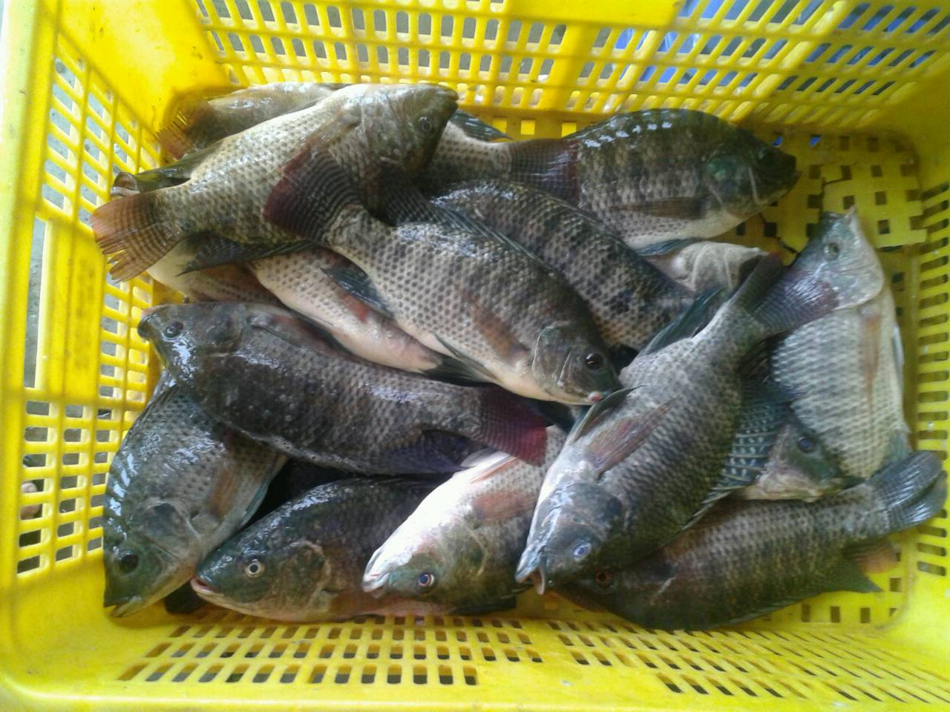
AQUACULTURE / WILD CAUGHT | Aquaculture
STATE or REGION LANDED / FARMED | Taiwan
FISHERY NAME (WILD CAUGHT) / COMPANY NAME (FARMED) | Several
MANAGEMENT (REGULATORY AUTHORITY) FOR WILD CAUGHT PRODUCT / AQUACULTURE COMPANY NAME FOR FARMED | BSMI
SUSTAINABLE? (i.e Global Gap, BAP, ASC, or MSC) | N/A

FINISHED PRODUCT FORMULATION
Please note a full breakdown of compound ingredient is to be qualified this is to include all allergens, additives, etc. that are present e.g. Beef Booster (Wheat Flour, Soy Lecithin (322), Emulsifiers (471, Colours (160a, 150c) Salt, Flavour Enhancers (631)…,)

PRODUCT FORMULATION INGREDIENT | QUANTITY (%) | COUNTRY OF ORIGIN
Tilapia (Oreochromis mossambicus) | 100% | Taiwan
PRODUCTION FLOW CHART (Please attach the copy of HACCP Plan)
Attached HACCP plan
COOKING INSTRUCTION
Please list any cooking time and temperature(s) to ensure that this product complies with the Food Standards Code
PRODUCT PICTURES
Fresh Tilapia Frozen Tilapia
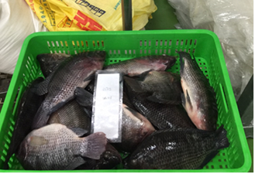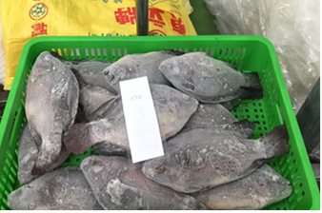

PACKAGING INFORMATION
Inner packaging
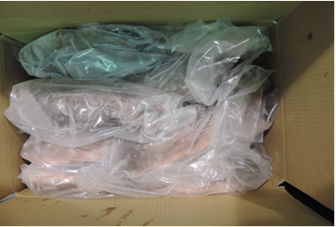

Package material | Transparent plastic bag
Package dimensions(mm) HxWxL | 190*400mm & 250*500mm
Products label (artwork | N/A
Inner bar code | N/A
Pack size/weight/volume | 600/800 800/1000 1000/1200 1200/1500 1500+

Outer packaging
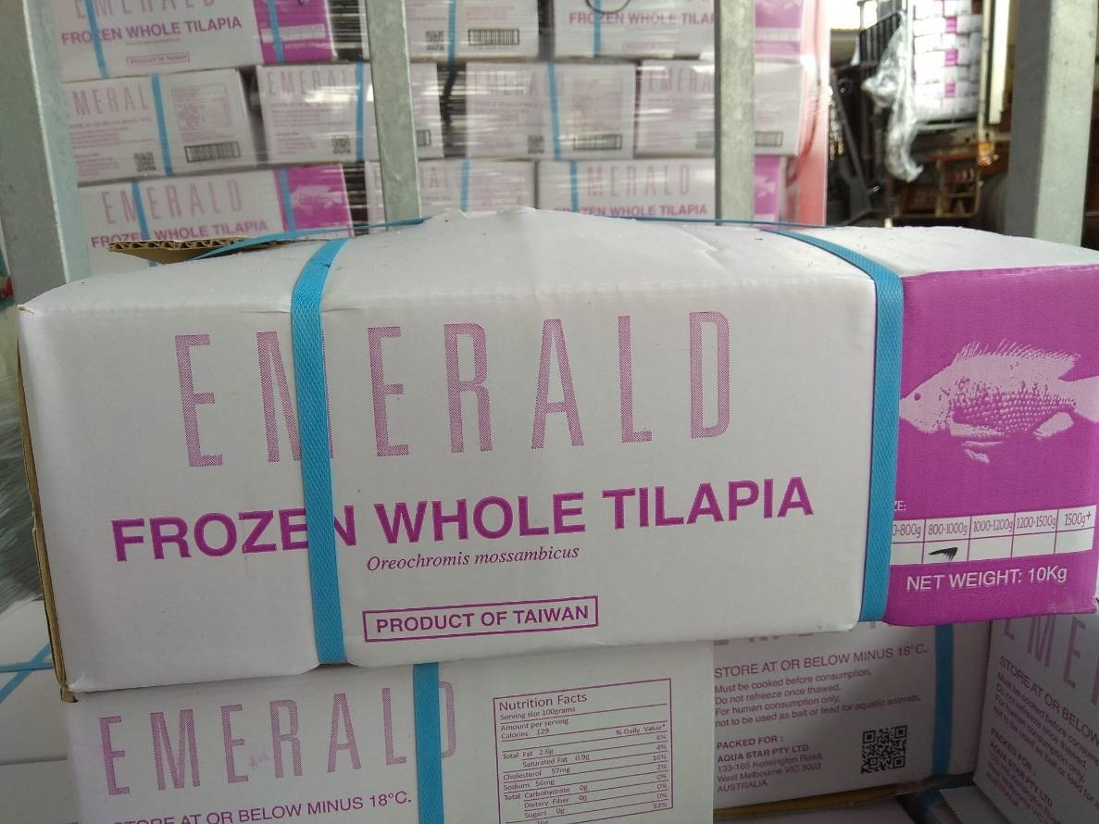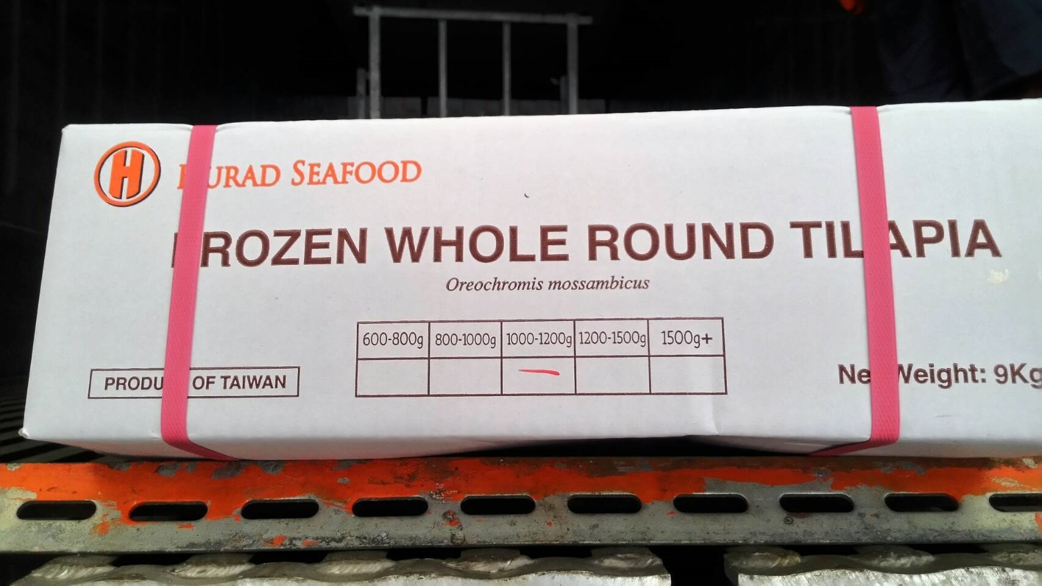

Package material | Water resistant double corrugated carton
Package dimensions(mm) HxWxL | 9K 470*380*150 mm 10K 470*380*160 mm
Products label (artwork) | 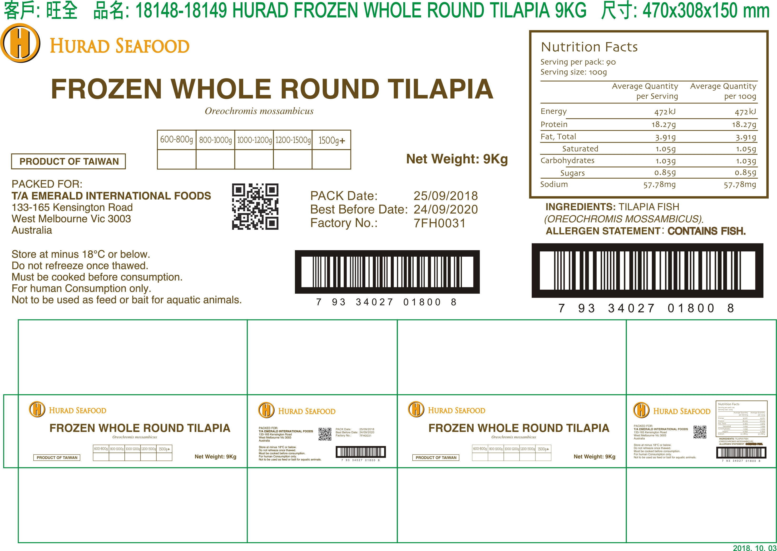  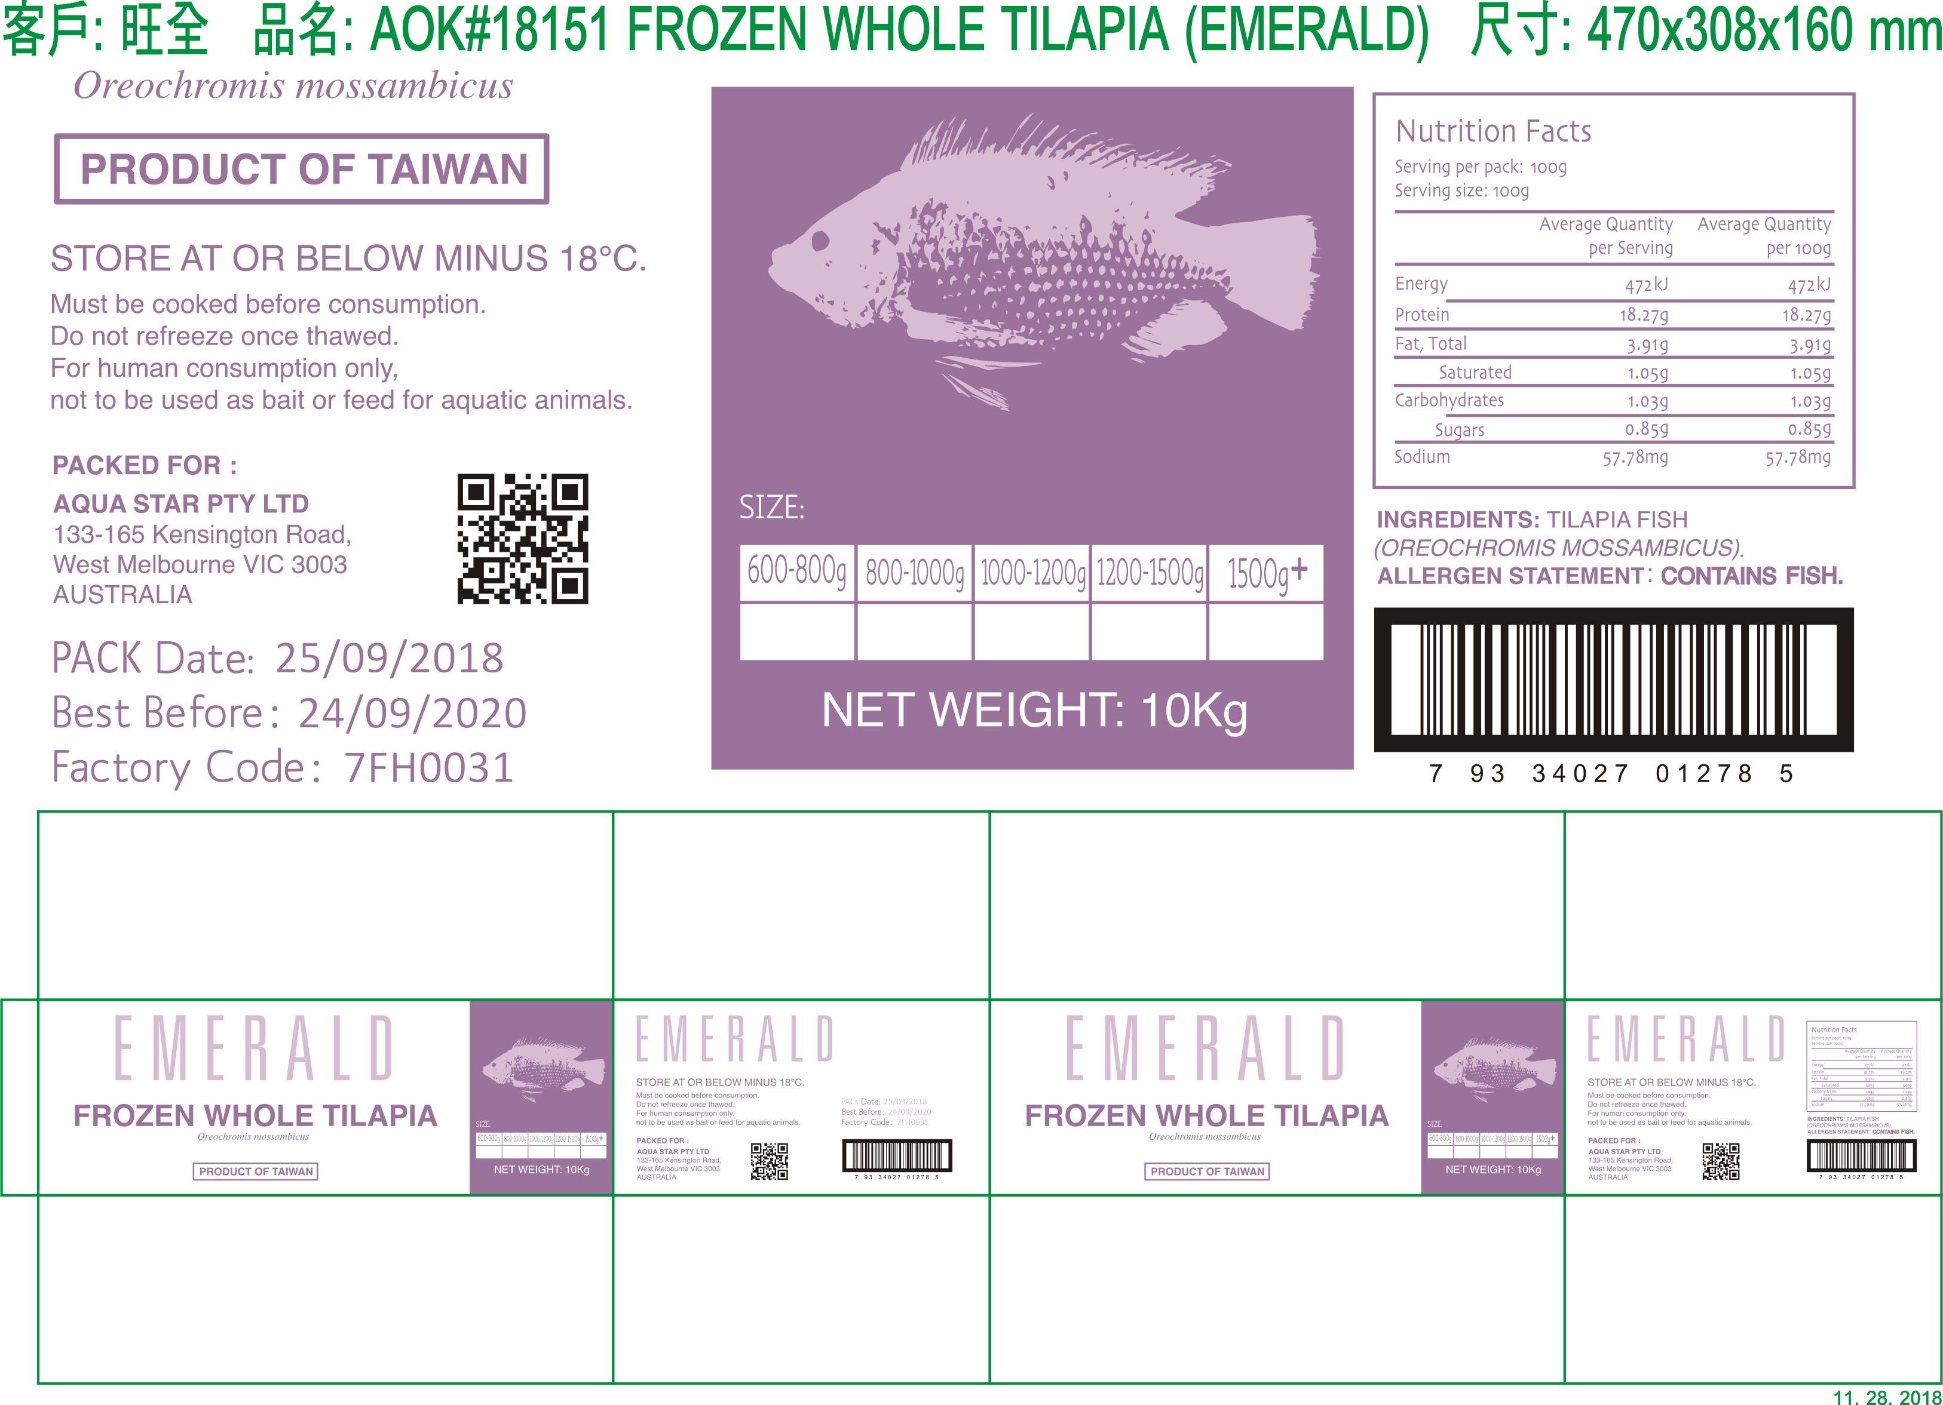
Outer bar code | N/A
Pack size/weight/volume | 9/10KG

PRODUCT LABELLING DETAILS
INGREDIENT DECLARATION ON PACK | Tilapia (Oreochromis mossambicus)
CHARACTERISING INGREDIENTS  What are the key characterising ingredients (%)? | Tilapia (Oreochromis mossambicus) 100%
GENETICALLY MODIFIED PRODUCTS (GMO)  Is this product required to identify any issues related to Gene Technology in accordance FSANZ Food Standards Code Standard 1.5.2? | NO
Does the product contain any irradiated ingredients? | NO
MANDATORY AND ADVISORY WARNING STATEMENTS  Is this product required to list any statements in accordance with FSANZ Food Standards Code Standard 1.2.3? | Allergy advice: Contains fish
DATE CODING / TRACEABILITY eg. (BATCH CODING, DATE, Lot No.) | Best before date: DD/MM/YYYY  Production Date: DD/MM/YYYY
NUTRITION/HEALTH & MARKETING CLAIMS  Are there any proposed statements relevant to the nature of the product listed? | NO
Country of Origin Statement | Product of Taiwan
OTHER WARNING STATEMENTS | For Human Consumption Only- Not to be used as Bait or as Feed For Aquatic Animals.

MANDATORY DECLARATION OF CERTAIN SUBSTANCE
FOOD  (present as an ingredient, additive or processing aid) | Present in the product  (Y/N) | Specify name and type of derivative/s | Specify % derivative in the finished product | Specify % total protein in allergen derivative
Cereals containing gluten ( i.e. wheat, rye, barley, oats, spelt) | N |  | % | %
Shellfish (Crustacean or Mollusc) | N |  | % | %
Egg | N |  | % | %
Fish | Y | Tilapia (Oreochromis mossambicus) | 100% | %
Milk | N |  | % | %
Peanuts | N |  | % | %
Soybeans | N |  | % | %
Sulphites | N |  | % | %
Tree Nuts and products | N |  | % | %
Sesame seeds | N |  | % | %
Lupin | N |  | % | %

ALLERGEN CROSS CONTACT : Refer to VITAL procedure and decision tree http://www.allergenbureau.net/allergen-guide/
FOOD | Present on the same line  (Y/N) | Present in the same factory  (Y/N) | Specify name and type of derivative/s | Estimate total protein from allergenic derivative in mg/kg (ppm) (Using Vital Procedure)
Cereals containing gluten ( i.e. wheat, rye, barley, oats, spelt) | N | N
Shellfish (Crustacean or Mollusc) | N | N
Egg | N | N
Fish | N | Y | Milkfish, Barramundi. Squid
Milk | N | N
Peanuts | N | N
Soybeans | N | N
Sulphites | N | N
Tree Nuts and products | N | N
Sesame seeds | N | N
Lupin | N | N

NUTRITION INFORMATION
Please Confirm if the NIP information provided below is based on theoretical calculation or external test report? |  | Please attach a recent test report
 |  | Average  QUANTITY PER SERVE | Average  QUANTITY PER 100G
ENERGY | kJ |  | 472
PROTEIN | g |  | 18.27g
FAT | TOTAL g |  | 3.91g
FAT | SATURATED g |  | 1.05g
FAT | TRANS g
FAT | POLYUNSATURATED g
FAT | MONOUNSATURATED g
CARBOHYDRATE | g |  | 1.03g
SUGARS | g |  | 0.85g
DIETARY FIBRE | g |  | 0g
SODIUM | mg |  | 57.78mg
Insert any other nutrient to be declared where applicable |  | All Nutritional Claims must be substantiated by nutritional data (eg. Low Cholesterol Product)

PRODUCT HANDLING REQUIREMENTS
TEMPERATURE REQUIREMENTS | Keep frozen. Store at or below -18ºC.
SHELF LIFE | 2 years
STORAGE & HANDLING REQUIREMENTS | Keep frozen. Store at or below -18ºC.

QUALITY CRITERIA
Physical Shape | Tilapia whole ronud
Appearance | Head on, scale on, gut in, whole firm meat
Flavour | Good
Colour | Good
Aroma | Good
Texture | Good
Defects | 0%
Size  (e.g. weight range for each piece) | 600/800 800/1000 1000/1200 1200/1500 1500+
Pieces per pack | Average: 20pc / 14pc / 11pc / 9pc / 7pc

ANALYTICAL CRITERIA Please attach a recent test report
(Products must be fully defined from a safety, quality and regulatory perspective)
CHEMICAL  ( eg. pH, Moisture) | CRITERIA | Test Frequency | TEST METHOD REFERENCE:
Arsenic (inorganic) | Less than 2 mg/kg | First production & every 12 months
Lead | Less than 0.5mg/kg | First production & every 12 months
Mercury | Less than 0.05mg/kg | First production & every 12 months
Histamine | Less than 200 mg/kg | First production & every 6 months
Fluoroquinolones | Less than 1.0ug/kg | First production & every 6 months
Chloramphenicol | Less than 0.1ug/kg | First production & every 6 months
MICROBIOLOGICAL  (Quality and Food Safety Parameters) | CRITERIA |  | TEST METHOD REFERENCE:
Total Plate Count (cfu/g) | Less than 500,000 | First production & every 6 months
E. Coli (cfu/g) | Less than 100 | First production & every 6 months
Coagulase positive staphylococci cfu/g | Less than 100 | First production & every 6 months
Staphylococcus/g | Less than 0/25g | First production & every 6 months
Salmonella/25g | NOT DETECTED | First production & every 6 months
Listeria/25g | NOT DETECTED | First production & every 6 months
Vibrio Cholera/25g | NOT DETECTED | First production & every 6 months
Vibrio parahaemolyticus | NOT DETECTED | First production & every 6 months
Enterobacteriaceae cfu/g | Less than 100 | First production & every 6 months
White spot virus | Not detected | Every batch
Yellow head virus | Not detected | Every batch
PHYSICAL  ( e.g.. Foreign objects) | Product must be free from foreign objects  Metal chip (size of metal chip): | Every pack | Metal detection, Processing Finished Product Quality Check SOP

APPENDIX
DOCUMENT COMPLETED BY: | Belinda Hsiao | CONTACT PHONE OFFICE : | +886 7 5538466
POSITION: | Sales Manager | CONTACT EMAIL: | exp1@aokingdom.com
CONTACT PHONE (M) | +886 975 591078 | ISSUE DATE : | Mar. 24 , 2021

Completed by Aqua Star:
DOCUMENT Approved BY: |  | CONTACT PHONE OFFICE :
POSITION: |  | CONTACT EMAIL:
CONTACT PHONE (M) |  | ISSUE DATE :

