|  |  |  |  |
| --- | --- | --- | --- |
| **DATE:** | **VERSION:** | **PRODUCT NUMBER:** | **PRODUCT NAME:** |
| **23/05/2024** | **2** | **1-790** | **Individual Red Velvet Cake** |

|  |
| --- |
| **PRODUCT DESCRIPTION** |
| A moist red velvet cake flavoured with hints of vanilla and chocolate. The cake is complimented with a delicious white chocolate cream cheese icing and crumbed red velvet. |

|  |
| --- |
| **PRODUCT INGREDIENT DECLARATION** |
| Ingredients: Sugar, **Wheat** Flour (Vitamins (Thiamin, Folate)), White Compound Chocolate (Sugar, Vegetable Fat, **Milk** Solids, Stabiliser (492), Emulsifier (322 (**Soy**)), Natural Vanilla Flavouring), Butter (Cream (**Milk**), Water), Canola Oil, **Egg**, Thickened Cream (Cream (**Milk**), Gelatine), Butter (Contains **Milk**), Cream Cheese (Contains **Milk**, Stabilisers (410, 412)), Colour (Contains Glycerine (422), Carmine (120), Citric Acid (330)), Icing Sugar, **Milk** Powder, Shortening (Contains **Soy**, Emulsifiers (435, 471), Antioxidant (307b)), Cocoa Powder, Vinegar, Vanilla Essence (Contains Colour (150d), Food Acid (330), Preservative (202)), Raising Agent (500), Fructose, Salt (Contains Anticaking Agent (554)), Glycerine, Preservative (202). |

|  |
| --- |
| **ALLERGEN DECLARATION** |
| **Contains**Gluten, Wheat, Egg, Milk, Soy.  **May Contain** Almond, Hazelnut, Macadamia, Pecan, Pistachio, Walnut. |

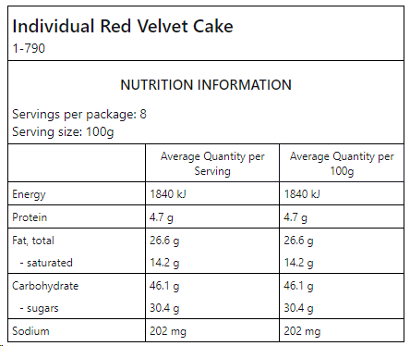

|  |  |  |  |  |
| --- | --- | --- | --- | --- |
| **PRODUCT SPECIFICATIONS** | | | | |
| **Individual Product Weight** | 100g | | | |
| **Inner Product Weight** | 800g | | | |
| **Carton Weight** | 4.80kg | | | |
| **No. of Units per Inner** | 8 | | | |
| **No. of Inners per Outer** | 6 | | | |
| **Pallet Dimensions** | Ctns per Layer: 4 | No. of Layers: 7 | | Ctns/ pallet: 28 |
| **Barcodes**  **(Including check digit)** | EAN 933104302389(5) | TUN 1933104302389(2) | | |
| **Shelf life** | Primary: 364 days | Secondary: 5 days chilled | | |
| **Inner Dimensions (m)** | Height: 77mm | Length: 375mm | Width: 200mm | |
| **Outer Dimensions (m)** | Height: 166mm | Length: 610mm | Width: 389mm | |
| **Inner Packaging** | Corrugated Fibre Board | | | |
| **Outer Packaging** | Corrugated Fibre Board | | | |
| **Country of Origin** |  | | | |
| **Methods of Preservation** | Frozen | | | |
| **Halal Status** | Suitable not Certified | | | |

|  |
| --- |
| **MICROBIAL SPECIFICATIONS** |
| |  |  | | --- | --- | | Parameter | Specification | | Standard Plate Count | <1x104 cfu/g | | Yeast and Mould | <1x103 cfu/g | | Coliforms | <100 cfu/g | | E. coli | <3 cfu/g | | Listeria monocytogenes | ND in 25g | | Salmonella | ND in 25g | |

|  |
| --- |
| **LABEL SAMPLES** |
| **INNER LABEL SAMPLE** |
|  |
| **OUTER LABEL SAMPLE** |
|  |

|  |
| --- |
| **PRODUCT IMAGE:** |
|  |

**.**